* The App must be a JAVA application

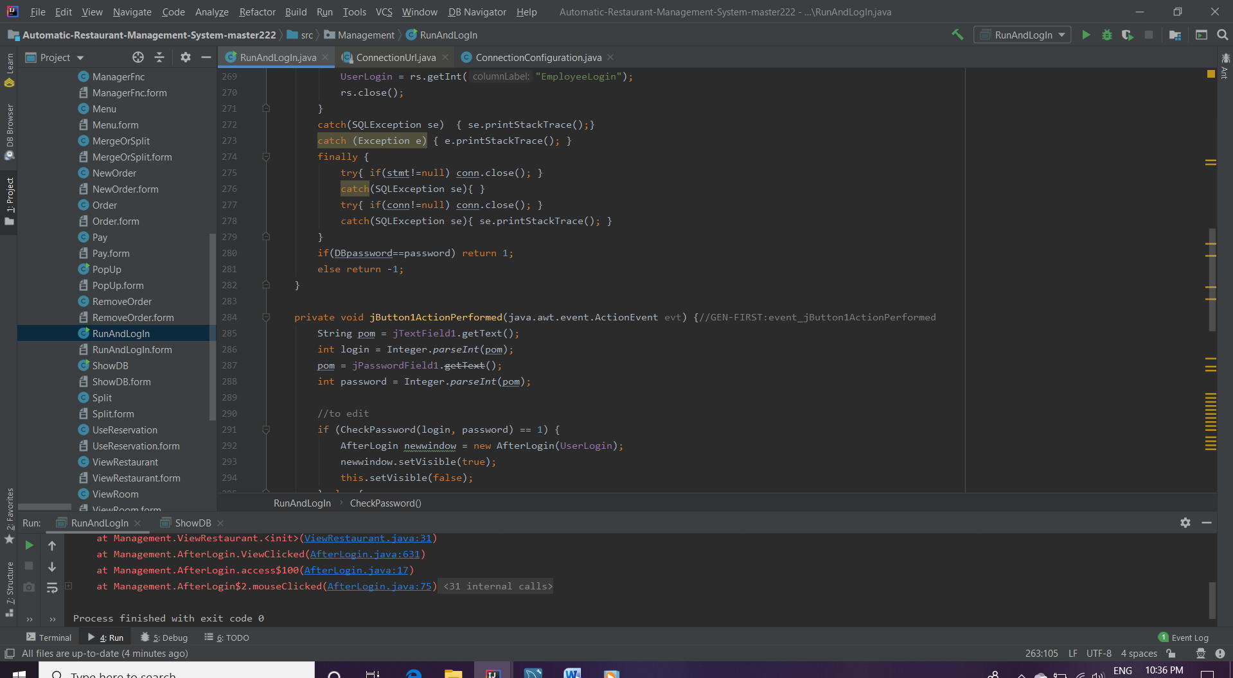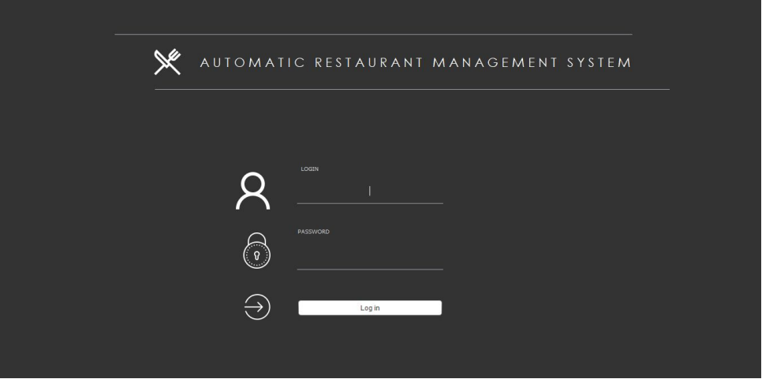

* The app will be used to make reservations to the restaurant

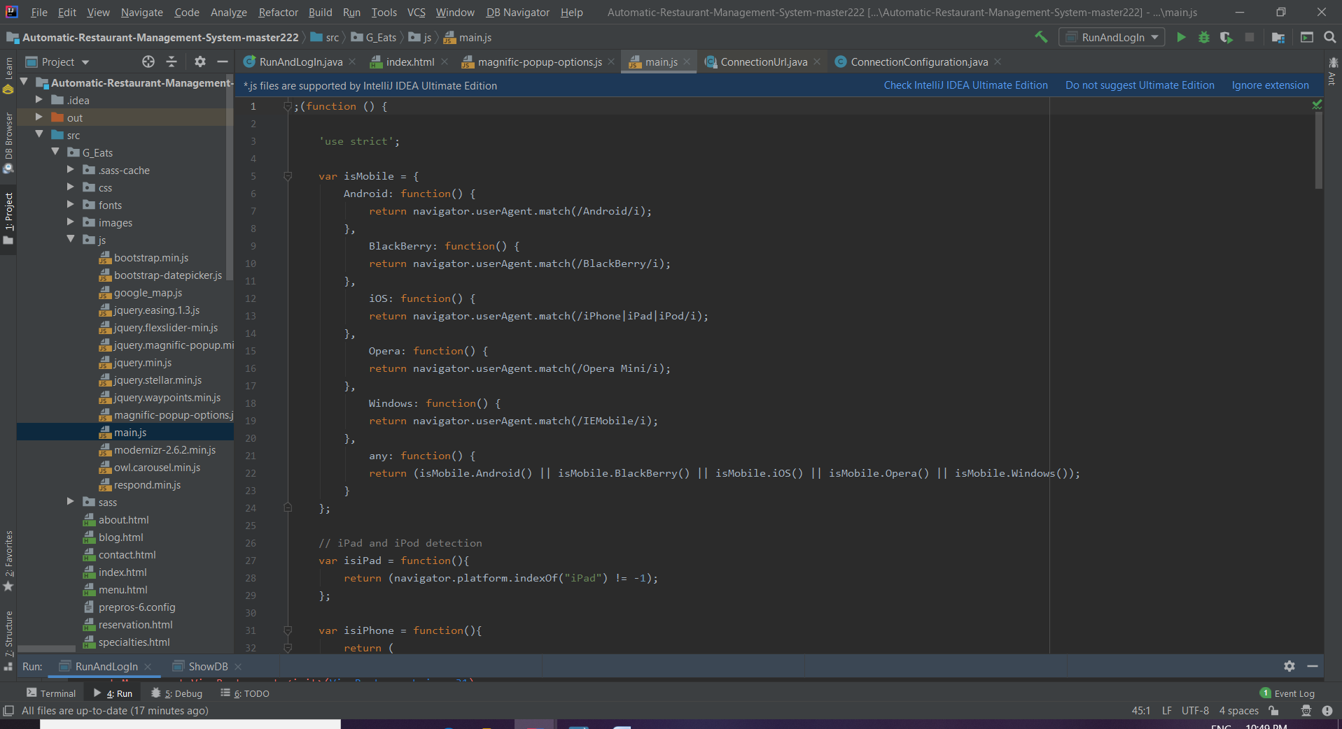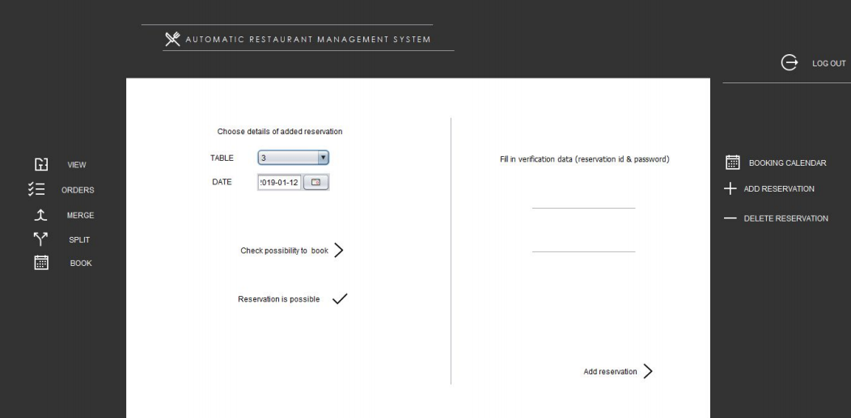

* The app must be linked to the internet and all changes and updates must reflect on the website

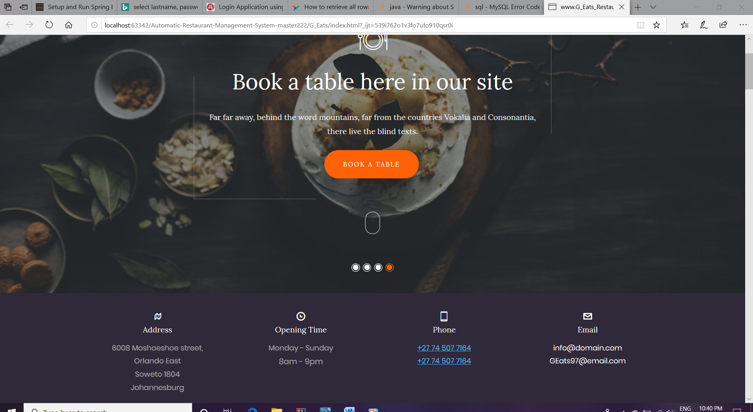

* The .jp file are linking the Automatic Restaurant Management System to my Html Pages



* The app must allow people to book a table as well as a time for their dinner reservation

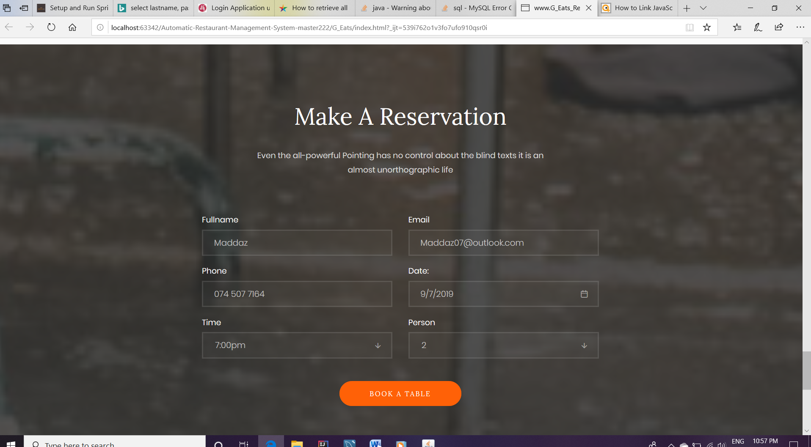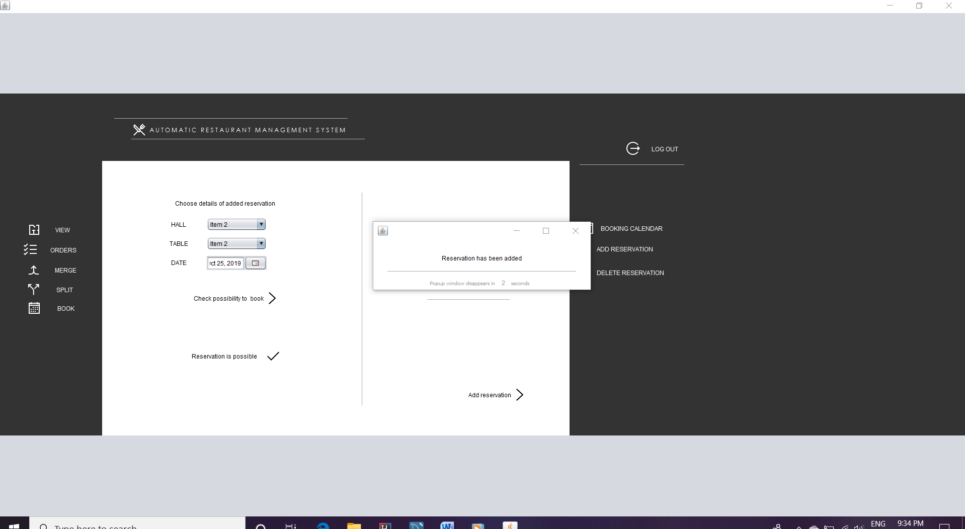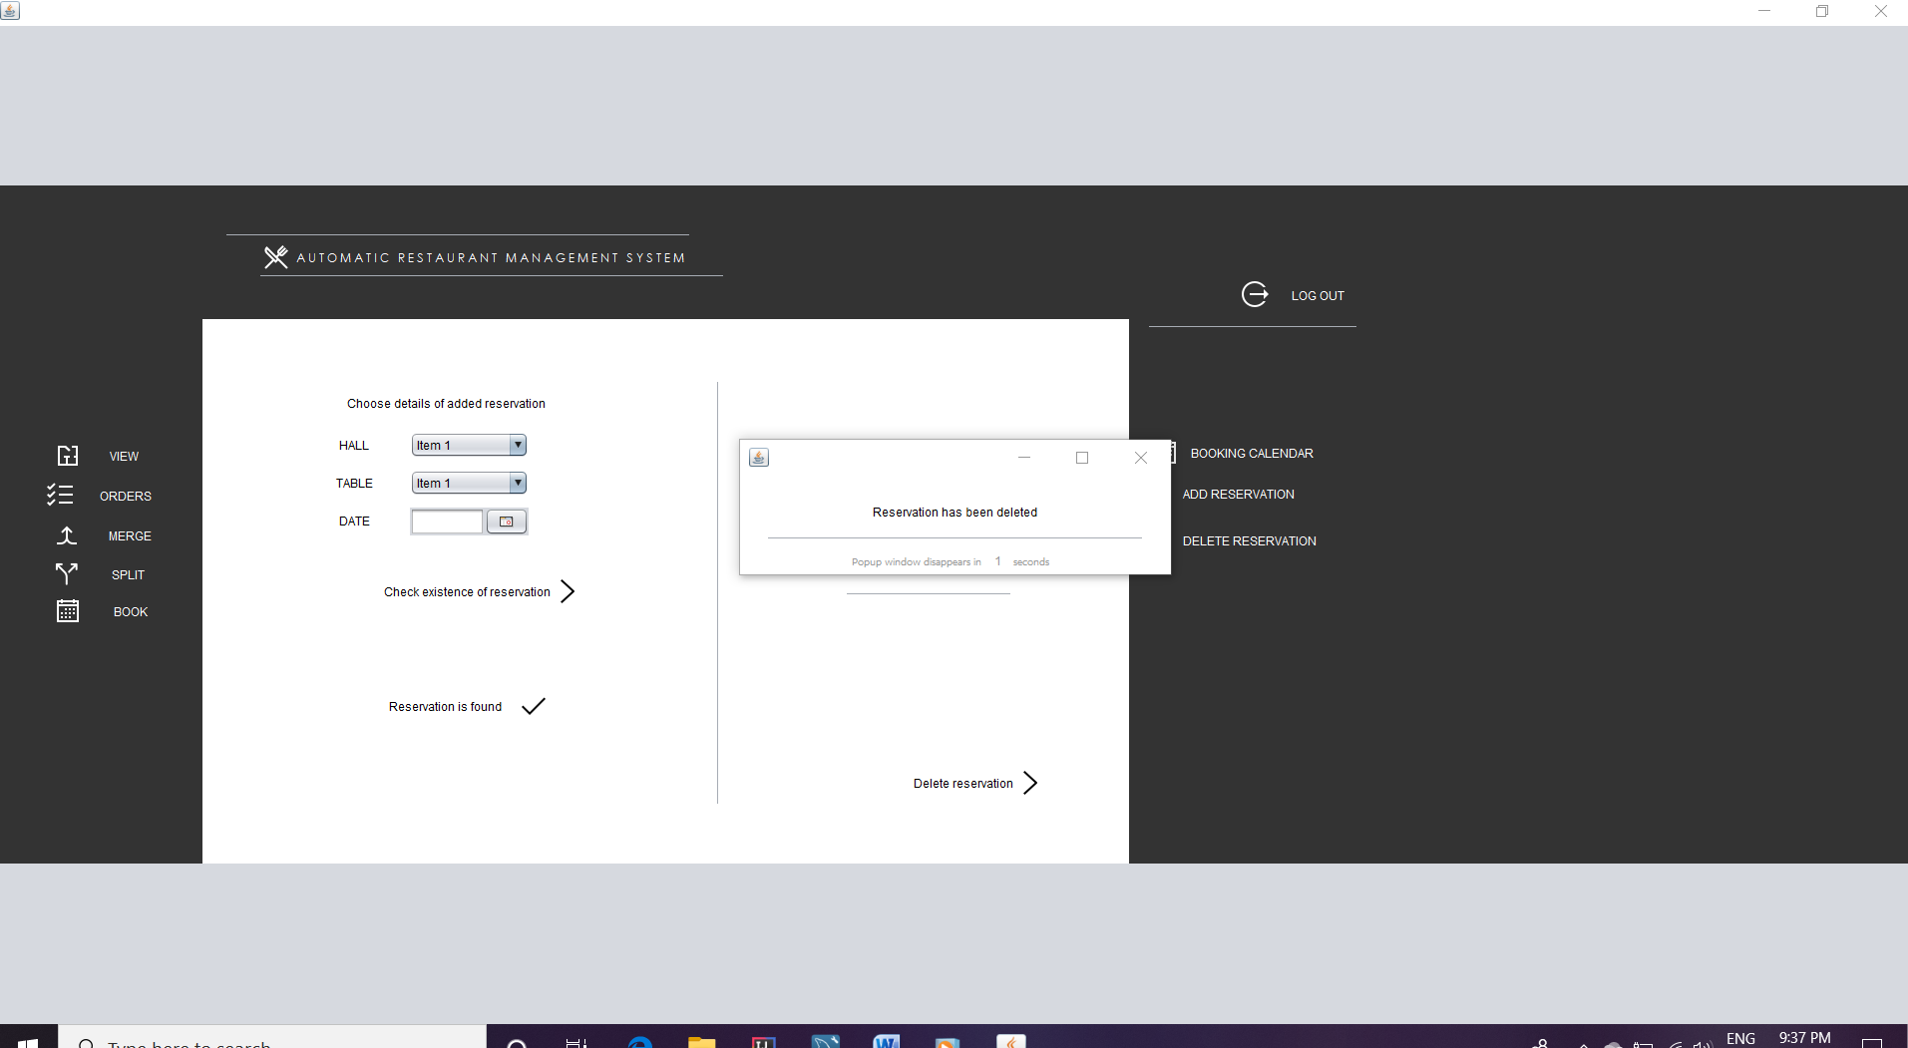

* Waiters must be able to login

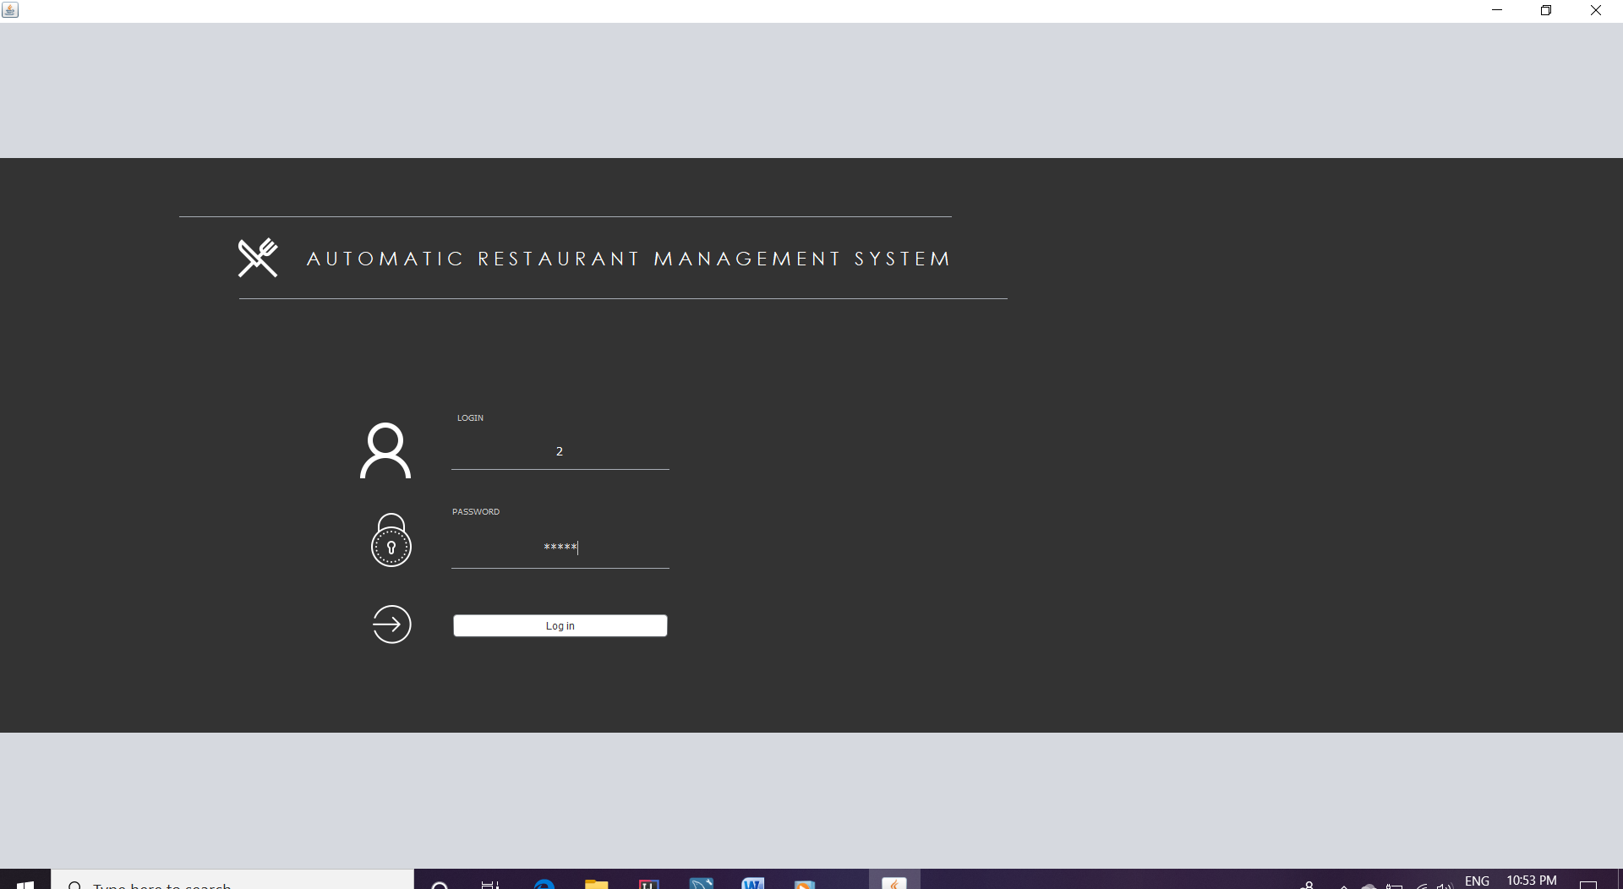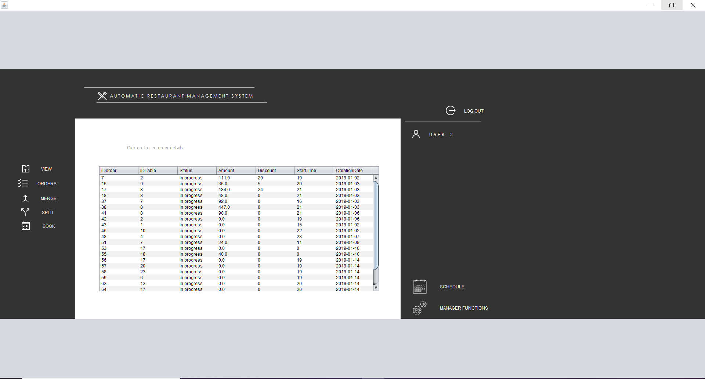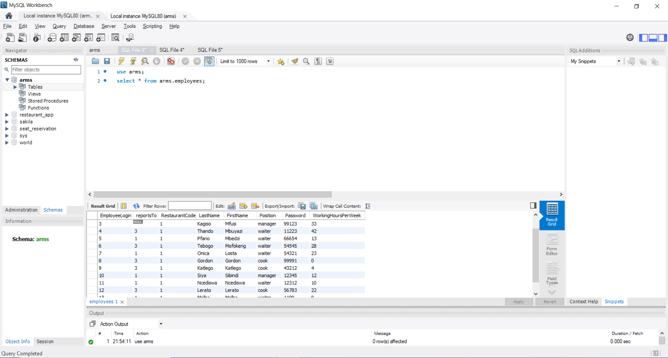

* Each waiter is assigned specific tables

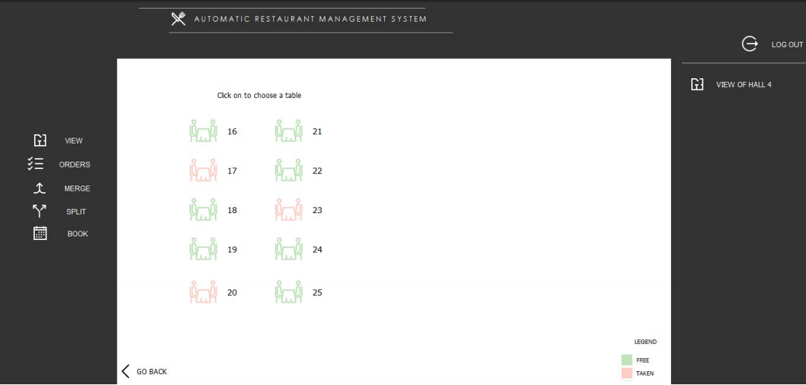

* A waiter must be able to add a list of things ordered for each table(Bill)

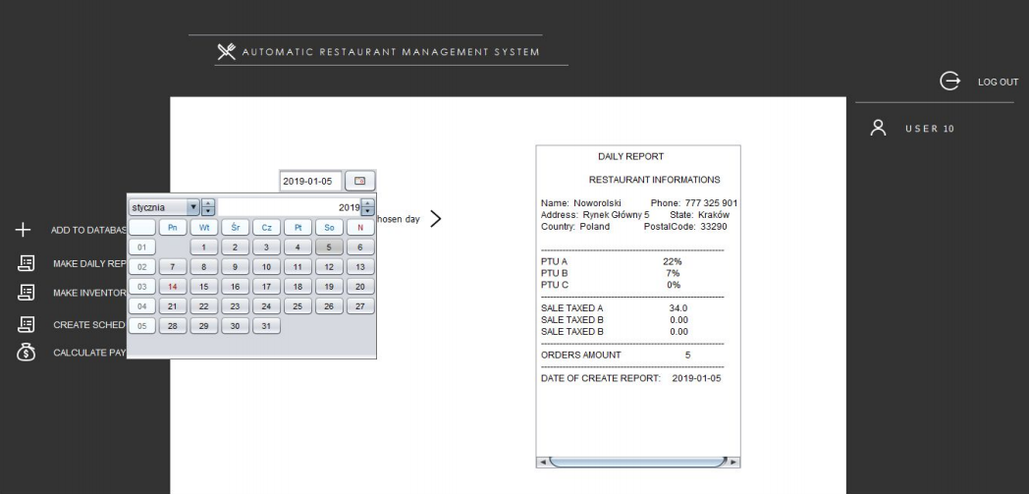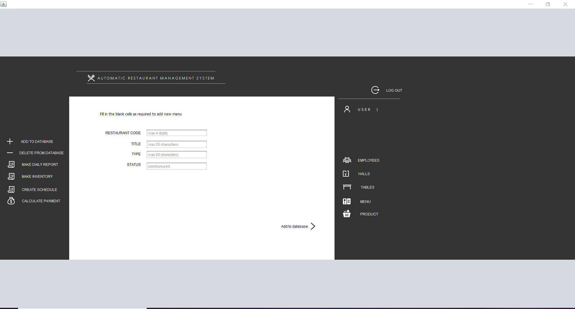

* A waiter must be able to search items to add to the bill of every table

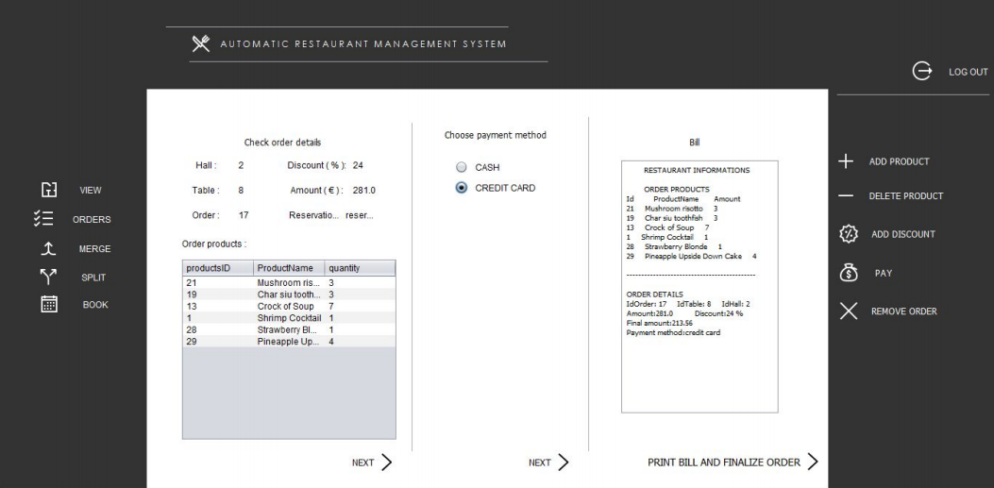

* The total for every item on the list must be calculated when the waiter clicks the checkout button



* All data must be saved in a database
* The DataBase is named arms.sql

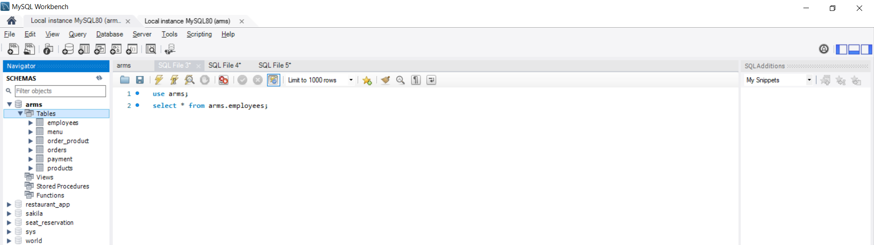

Specifications that your company has in place in order to do quality control:

* All Applications must make use of a class or classes in order to keep code clean and reduce the need to rewrite code this also includes inheritance



* No code should be inserted directly into events, rather they should be added to functions and methods and only get called in the events



The .jp files handle the event by linking them in HTML pages.

* Error prevention must be applied where possible

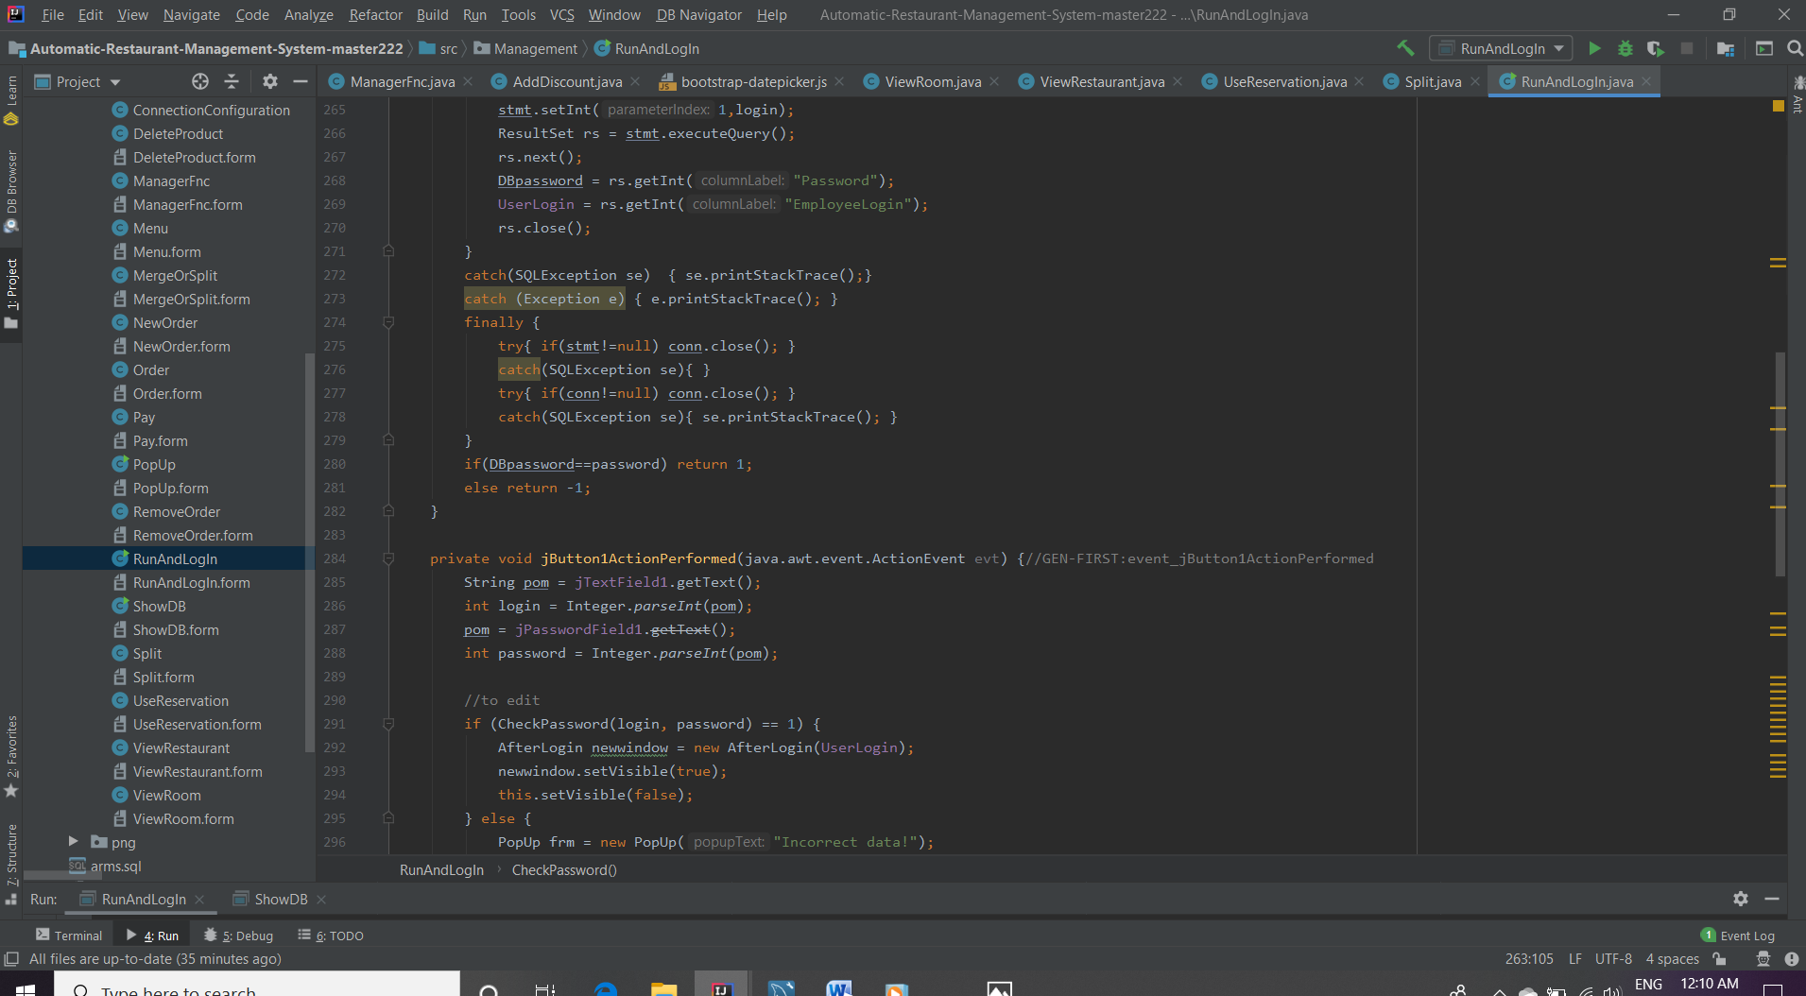

Exception Handling methods.

* Application must be able to check for and apply Updates

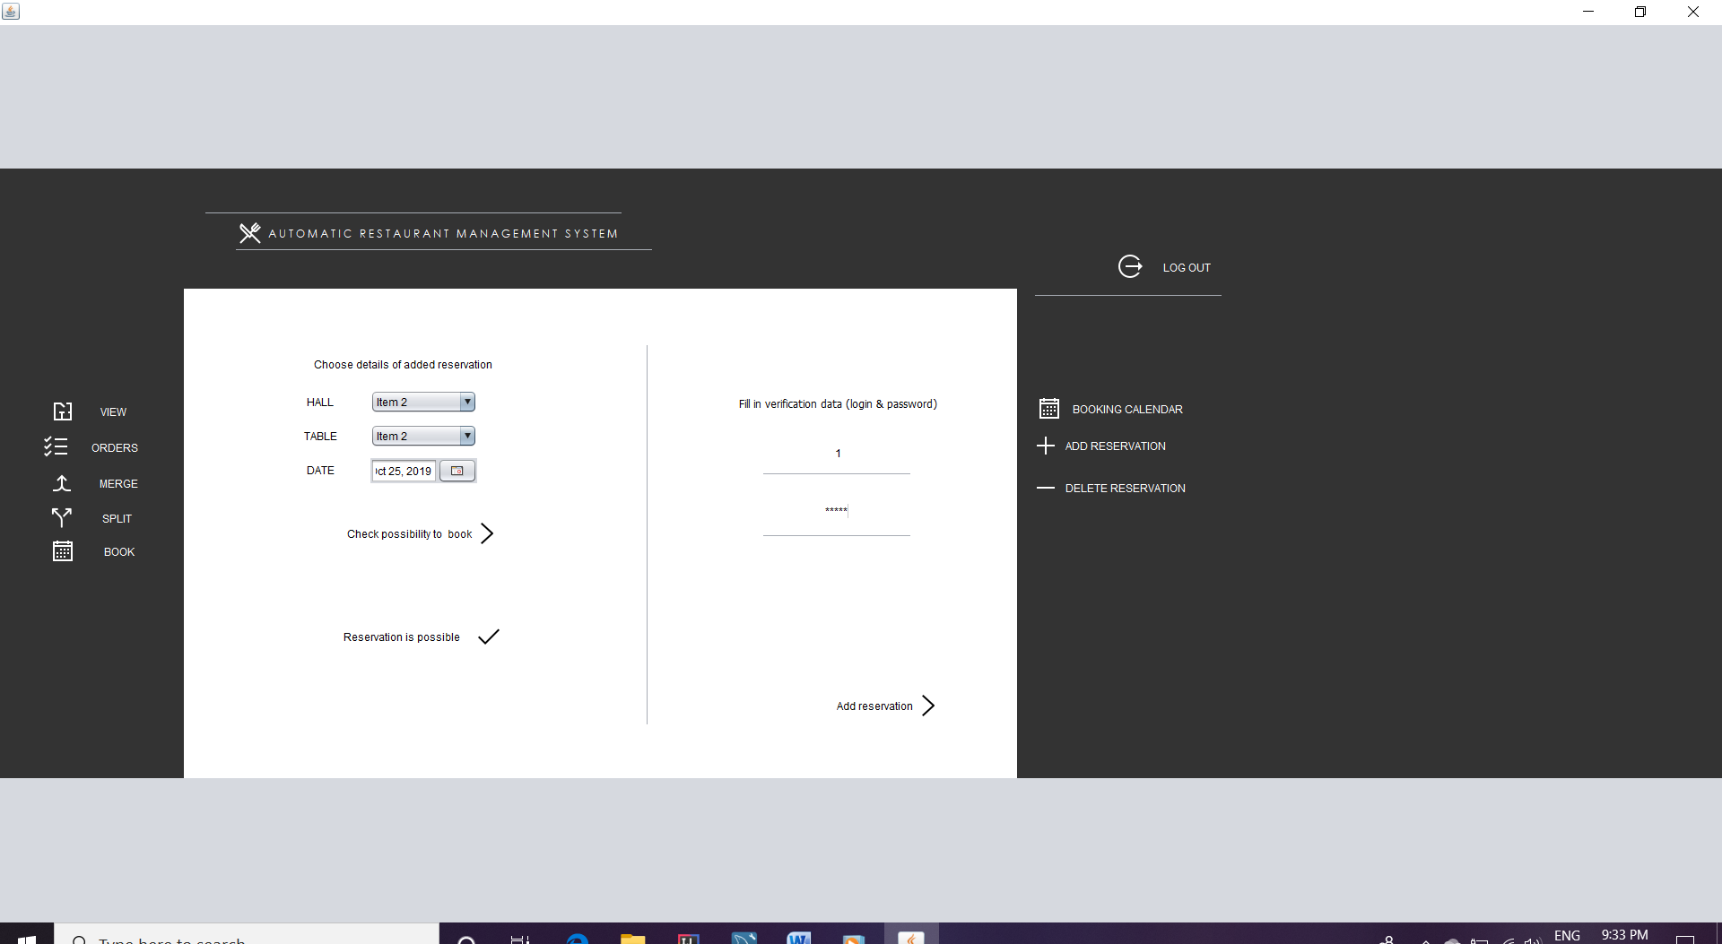

* Abstract data types must be used where possible
* In depth Testing manual must be created where the following must be included in the testing report:
* Test for calculation errors
* Record the results from testing a computer program.(Screenshots needed)
* List all errors encountered and how you got to the solution

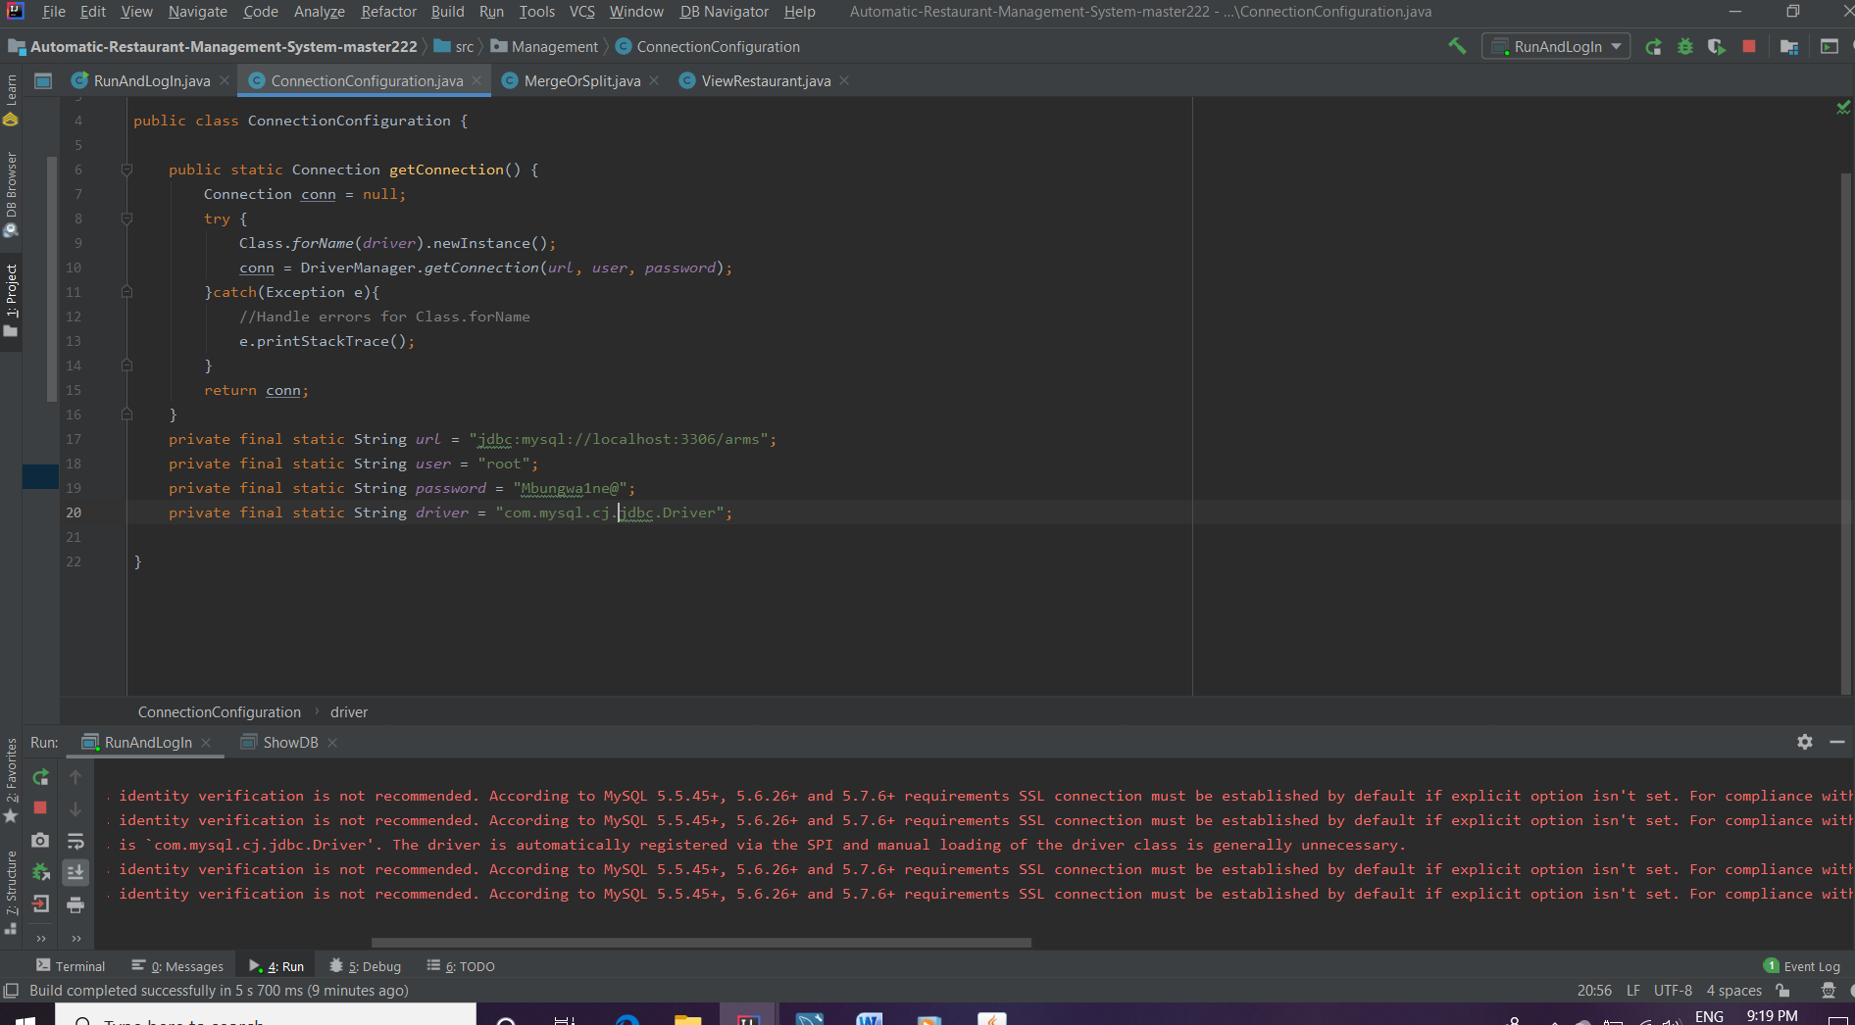

Download the .jar files.

* A comprehensive user manual must be created explaining and showcasing the app
* Thorough planning document must be created that includes the following:
* Application Flow
* Design choice as well as motivation as to choice made
* Application logic planning
* 
* Application database planning

